|  |  |  |  |  |  |
| --- | --- | --- | --- | --- | --- |
| **Key Vocabulary** | | | | | |
| **Dodging and weaving -** to move quickly up and down and from side to side, usually to avoid hitting or being hit by something. | Applying a **force** to the throwing object - A force acting on an object (throwing the javelin out of our hands) causes the object to start moving and accelerate away from us. | | **Personal Best** - means setting a goal, doing your best, and no matter the outcome, being satisfied with the level of effort you put into achieving your goal. | | **Isolation** - An isolated practice consists of focusing on one technique or skill at a time to practice and improve.  **Combination** - a coordinated and effective sequence of moves. |
| **What you need to be successful?** | | | | | |
| **Running for Distance** | | **Jumping for Distance** | | **Throwing- Push Throw** | |
| * To not set off too fast, and to establish a steady pace. * Keep to a steady running pace. | | * Jump as far as possible from a standing position, with a two-footed take-off. * Land on both feet. * Bend ankles, knees, and hips. * Keep eyes focused forward. * Swing arms behind body. * Straighten legs. * Both feet leave the ground together. * Arms swing forward and up. Land on both feet at the same time. * Ankles, knees and hips bend to absorb impact. | | * Spread fingers behind the object (ball, beanbag etc), which is held at the chest. * Push the ball away from the body by extending (straightening) the arms fast. * Transfer body weight from the back leg to front leg. * Follow through with the arms, wrists, hands, and fingers in the direction of the throw. * **Emphasise** the importance of applying a force to the throwing implement. | |
| **Building Blocks to Success** | | | | | |

**Pictures of Skills**

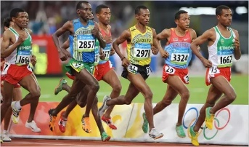

**Running (Distance)**

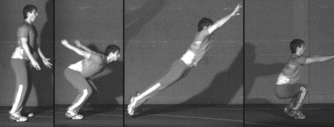

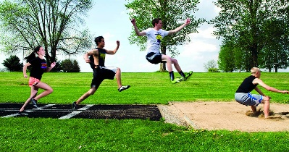

**Jumping (Distance) Technique**

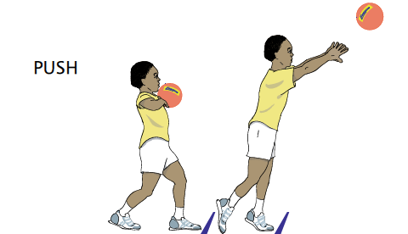

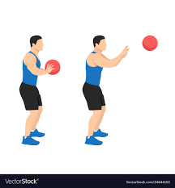

**Push Throw**

